SHL Conversational Assessment Recommendation Agent – Approach Document
Name – Bhawana

Section 1 (Problem Understanding): The objective of this project is to build a conversational agent that helps recruiters identify suitable SHL assessments even when they describe hiring needs in natural language rather than using exact catalog keywords. The system understands the user's intent, retrieves relevant assessments from the SHL catalog, and uses an LLM to generate conversational recommendations.

Section 2 (System Design):
System Design
The application is divided into several components:
- FastAPI backend
- SHL catalog scraper
- Embedding generation
- FAISS vector database
- Retrieval module
- Groq LLM integration
- REST API endpoints
The workflow is:
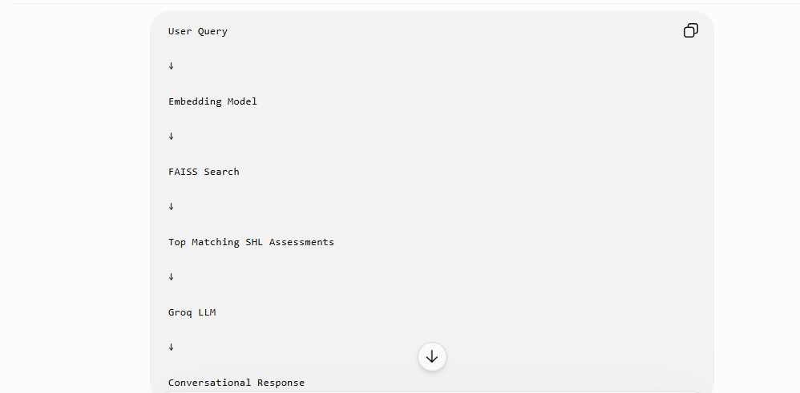
Section 3 (Design Choices):

Design Choices
- Python was selected for implementation because of its NLP ecosystem.
- FastAPI was used to expose REST endpoints.
- Sentence Transformers were used to create semantic embeddings.
- FAISS was chosen for efficient similarity search.
- Groq-hosted Llama model was used as the language model because it provides low-latency inference.
- Retrieval-Augmented Generation (RAG) was used to reduce hallucinations by grounding responses in retrieved SHL assessment data.

Section 4 (Retrieval Setup):

Retrieval Setup
The SHL assessment catalog was scraped and converted into structured JSON records. Each assessment contains fields such as:
- Assessment name
- Description
- Job level
- Skills
- Duration
Sentence embeddings were generated using the Sentence Transformers library and indexed using FAISS. At query time, the user's request is embedded and compared against the FAISS index to retrieve the most relevant assessments.

Section 5 (Prompt Design):
Prompt Design
The language model receives:
- The user's query
- Retrieved assessment information
- Instructions to recommend only assessments supported by retrieved evidence
The prompt encourages the model to:
- explain why each assessment matches,
- avoid unsupported recommendations,
- maintain a conversational tone,
- ask follow-up questions when the user request is ambiguous.

Section 6 (Evaluation Method) :

Evaluation Method
The system was evaluated using multiple natural language hiring queries, including:
- I need a Java developer.
- Hiring entry-level software engineers.
- Looking for leadership assessments.
- Need communication and teamwork tests.
The retrieved recommendations were manually verified to ensure they matched the intended hiring requirements.

Section 7 (What Did Not Work):

Challenges and What Did Not Work
Several approaches were explored during development.
- Keyword-only search often missed relevant assessments when users used different wording.
- Direct LLM prompting without retrieval occasionally produced unsupported recommendations.
- Initial retrieval quality was lower before semantic embeddings were introduced.
Using semantic search with FAISS and grounding the LLM with retrieved assessment data significantly improved recommendation quality.

Section 8 (How Improvement Was Measured):

Measuring Improvement
Improvements were measured by comparing retrieved assessment relevance across representative hiring queries. The final Retrieval-Augmented Generation pipeline produced more accurate and context-aware recommendations than keyword-based retrieval, while reducing irrelevant matches and unsupported LLM responses.

Conclusion: The final system combines semantic retrieval and Retrieval-Augmented Generation to provide accurate, explainable, and conversational SHL assessment recommendations. The architecture is modular, scalable, and can easily be extended with additional assessment data or larger language models.
However I could not deploy properly , it failed whilst I try to deploy.

